Mawlana Bhashani Science and Technology University
Santosh, Tangail -1902

Department of Computer Science and Engineering
Course Title: Computer Networks Lab
Course Code: CSE-3204
Report Title: Establishing LAN Connection
Date: 26-10-2024
Lab Report

Submitted To:
Prof. Dr. Mohammad Motiur Rahman
Professor
Department of Computer Science and Engineering
MBSTU
Submitted By:
Md. Mustakim Mia(CE21004)
Alamgir Hosain(CE21012)
Md. Nahid Riaj(CE21037)
Md. Shajib(CE21053)
Iffat Jinnat Badhon(CE21057)
Year: 3rd Semester: 2nd
Session: 2020-2021

LAN(Local Area Network)

LAN: A LAN is a collection of devices connected together in one physical location, such as a building, office or home.
Note : LAN is typically created via Ethernet/Wifi.
Establishing LAN Connection:
To establish a Local Area Network (LAN) connection between two or more devices (like computers), we are following these step-by-step instructions:

Step-1: Necessary Networking Devices

Ethernet port: Ensuring each device has Ethernet port.
UBS Ethernet Adapter: Some devices doesn’t have Ethernet port. So, the cable need to connect using USB Ethernet Adapter. For this we need to install Ethernet To USB in our system. Here is the following steps:
Device ManagerOther DevicesUSB.20UpdateBrowse DriveGive the software FoderInstall

Ethernet Cable(s): It's a wired LAN, that is why we need Ethernet cables(CAT-5/CAT-6/..).
We basically used, Cat-6 UTP(Unshielded Twisted Pair) Cable.
Switch: A switch is a computer devices that connect multiple devices. That’s why for connecting multiple devices, we use a switch.

Step-2: Physically Connect the Devices
- We Plug one end of the Ethernet cable into the Ethernet port of the first device.
- Then we Plug the other end into a port on the switch.
- Repeating the process for each device to connect them all to the switch.

Figure:
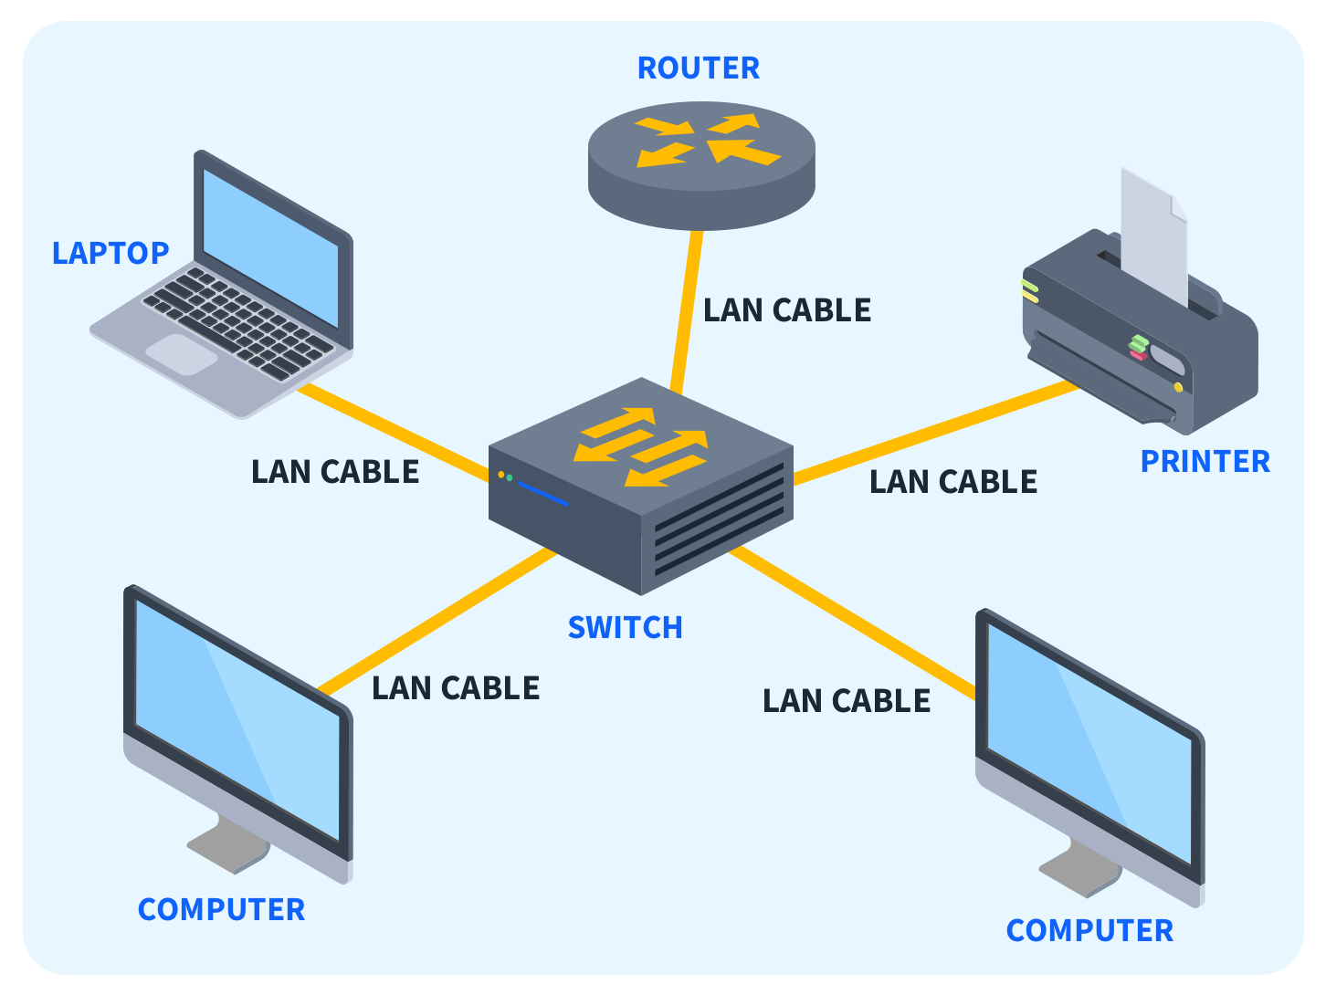

Step-3: Configuring IP Addresses
On each device, ensuring that the network adapter is set to obtain an IP address:
For Windows: Control Panel Network and Internet Network and Sharing Center Change Adapter Settings Ethernet Properties Internet Protocol Version 4(TCP/IPv4) properties Use the following IP address Then setup the following IP address for each devices :
- IP address : 192.168.0.3
- Subnet Mask : 255.255.255.0
Similarly for each devices.

Step-4: Testing the Network Connection

Ping Test:
On each device, opening the command prompt.
Type: ping [IP address of another device] >>press enter
Ex: ping 192.168.0.4
We receive replies, So the LAN connection is established successfully.

Step 5: Sharing Files and Resources

Control Panel > Network and Sharing Center > Click on Change advanced sharing settings and enable file and printer sharing.

5.1 Using UI:
- Select the Folder to be share.
- Go to properties
- Go to sharing
- Select Everyone
- Then Go to Advance Sharing
- Mark Share the Folder
- Give Share name and Permission
- Permit Everyone and Gives the full control(or Read only).
- Apply and then OK.

5.2 Using Command Prompt:
- Give Only For Read : net share Full="C:\Users\user\Downloads" /grant:Everyone,read
- Give the Full control : net share Full="C:\Users\user\Downloads" /grant:Everyone,full
- Gives Administrator Permission : icacls "D:\CProgram\CSE camp" /grant Everyone:(OI)(CI)F /T
- Delete the Folder : net share Full /delete

Setp-6 : Comparison
Attribute | CAT 3 | CAT 5 | CAT 6 | CAT 7
Cable Type | UTP | UTP | UTP or STP | FTP
Max,Data Transmission Speed | 10Mbps | 10/100/1000Mbps | 10/100/1000Mbps | 10,000Mbps
Max Bandwidth | 16 MHz | 100 MHz | 250 MHz | 600 MHz
6.1 Comparison Table of CAT 3, CAT 5, CAT 6 and CAT 7

6.2 Comparison table of Fibre Optic, Coaxial, twisted Pair and Copper Cable
Feature
  Fiber Optic
  Coaxial Cable
  Twisted Pair
  Copper Cable
Material | Glass or plastic fibers | Copper core with insulation and shielding | Copper wires (twisted in pairs) | Pure copper wires (untwisted)
Data Transmission | Transmits light signals (optical data) | Transmits electrical signals | Transmits electrical signals | Transmits electrical signals
Speed & Bandwidth | Very high speed (up to 100 Gbps and beyond), large bandwidth | Moderate speed (up to 1 Gbps), medium bandwidth | Moderate speed (up to 1 Gbps for CAT 6), medium bandwidth | Moderate speed, depending on use and quality
Common Use | long-distance data transmission | Cable TV, broadband internet,short- distance | Ethernet networks (LAN) | Electrical wiring, some telecommunications applications

